Wilton DTC Minutes
May 9, 2017

Comstock Community Center

Call to Order: 7:32 PM call to order by Deb McFadden, Chair. Quorum achieved at 7:50 PM

Attendance.
Members: Deborah McFadden, Leslie Holmes, Ross Tartell, John Kalamarides, Charlie Lewis, Hermon Telyan, Dan Troph, Florence Johnson, Jackie Kremer, Tom Burgess

Guests: Margaret Creeth, Deborah List, Brad Williams, Melissa Spohn, Peter Squitteri, Annette Sterling, Andy Gundell, Patrice Gillespie, Pam Hovland, Rowan Kane, Ceci Maher, William Tong, Carole Young-Kleinfeld, Alexander Rappaport

State Representative William Tong. Representative Tong is Chair of the Judiciary Committee Chair of the Commission on Economic Competitiveness. His current work focuses on helping to strengthen legislation to reduce the increase in hate crimes. Representative Tong also spoke to the findings of the McKinsey & Company study that found that people wanted to be in cities and less in suburban areas, and how this was impacting the Connecticut’s business climate. He noted that the budget issues in Connecticut were “profound.” As part of his work, the Economic Development commission is committing to creating 500,000 jobs.

Representative Tong also added that President Obama and Eric Holder are leading the effort to take back the state houses and governorships. He emphasized the importance of having a Democratic majority if we are going to get Democratic work done.

Finally, he spoke to the necessity of grass roots efforts if Democrats are going to grow their presence in Connecticut and across the country.

The April 13, 2017 DTC minutes were unanimously approved.

Chair’s announcements:
June 6 meeting – back to first Tuesday
July 11 meeting – pushed a week due to 4th of July
September 9 – Democratic BBQ Schedule the BBQ for September 9th – motion seconded and passed unanimously Ross will be part of the committee. Committee still needs to be formed

Wilton voting results – 16.2% turnout. Everything passed.

Senator Murphy – Town Hall meeting May 13, 2:00 PM UCONN Stamford.

Website. Leslie Holmes updated the DTC on website matters. Facebook and website traffic is increasing. A request was made that when you go to the website, to share the links to increase exposure and traffic.

Treasurer’s Report. There is $2,459.14 in the bank. DTC breakfast revenue was $2,435 and expenses were $1,626.63. Profit was $808.37.

Connecticut Democratic Party dinner on June 10 in Hartford.

July Caucus must be held between July 18 and 25. At the caucus, the party will determine who to put on the ballot in November. If anyone is interested in running, they can contact Paul Burnham or Deb McFadden. There was a motion and a second to set the date for the Caucus on Tuesday July 18. The motion was unanimously passed. The caucus will start at 7:30 PM and is tentatively scheduled for Comstock. (The date has since been changed by the chair to July 19)

Chair Announcements. Deborah McFadden made several announcements regarding upcoming community and party events
Upcoming dates for manning booths:
June 11 – Georgetown Day (Brad will help man the booth)
A motion was made to participate in
July 4th – Booth at the High School (Deborah will participate)
July 15th Wilton Chamber of Commerce – Street Fair (Participation has already been approved) (Jackie Kremer will participate)

DTC Membership. Ross Tartell reported on the status of people being considered for inclusion in the DTC. While none were presented at this meeting, there are a number who will be presented for approval in June.

Nominating. May and June are busy months for nominating. We need to contact everyone whose term expires December 1 and ensure we have candidates to fill the open positions for the election. The DTC will have at least one candidate for Selectman.

Chris Stroup will not run again. The nominating Committee is in discussion regarding who they will nominate to run for Board of Education.

For P&Z, Doris Knapp will run again. Frank Wong is relocating and has resigned. The Nominating Committee has nominated Brian Lilly to run for Frank’s seat. We are waiting to hear from one more incumbent as to whether they will run.

Richard Creeth will run again for Board of Finance.

We are contacting candidates to fill Brian Lilly’s position on the ZBA.
Attached is a copy from Lori Klaback, Town Clerk, regarding number of candidates and positions that can be on the November ballot.
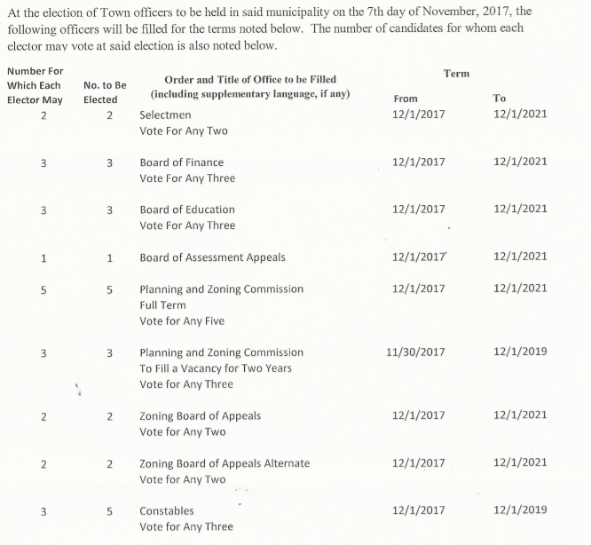

Board of Finance. John Kalamarides updated the DTC on current Board of Finance matters. They are pleased that the budget passed.

Website. Leslie Holmes updated the DTC on website matters. The new website is working well, though a few pages need to be further populated with information (especially certain action groups).

Communications. Bob Carney updated the DTC on communications matters, including the increasing reach of our social media accounts.

Action Group Updates. Updates were provided by the Upstander group, Gun safety, and fundraising.

New Business.

Deborah McFadden introduced Alexander “Zander” Rappaport, WHS student intern. He will be working with the DTC for four weeks.

P&Z Age restricted zoning on Ridgefield Road. There will be a continuation of the last P&Z meeting.

A motion was made for the DTC to recommend that P&Z meetings be broadcast on the public access channel. The motion was seconded and passed unanimously.

Action – Patrice Gillespie will poll the P&Z Commissioners as whether they have received P&Z land use training from UCONN.

John Kalamarides recognized and said thank you to Hermon Telyan for his excellent work creating gifts for the Democrat of the Year and Lifetime Achievement awards conferred on Richard Creeth and Gini Benin at the spring breakfast.

Adjourn – The meeting was adjourned at 9:13pm.

Minutes by Ross Tartell

